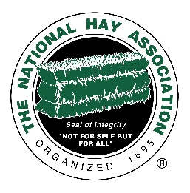
If you have never attended a NHA Convention or Mid-Year Meeting, this might be for YOU!
Thanks to the NHA Sponsorship Group and some very generous donors who provided the items for auctions at the 2022 Annual Convention, a sponsorship to attend the February 2023 meeting is available to one Full Member and a guest! All you have to do is fill out the application below and if you are chosen, you will be awarded the following:
- Travel to the meeting-either standard airfare or mileage-for up to two people
- Room charges at Kiawah Island for up to four (4) nights
- Sponsorship cannot exceed $2,000

Send your completed application to NHA Office. 4735 Massillon Rd Unit 769. Green, OH 44232. All applications must be received by Friday, January 20, 2023. The winner will be selected by January 27, 2023.
This application is intended to offer a member who has never attended a NHA convention, the ability to do so.

Have you ever attended a NHA Annual Meeting held in the fall of the year? ________ Yes _______ No
Have you ever attended a NHA Mid-Year Meeting held in the winter of the year? _______ Yes _______No
If you answered No to both of these questions, please continue on…
Company Name _____________________________________ When did you join the NHA? _______________
Your name __________________________________________
Address ___________________________________________________________________________________
Street Address City State Zip

Phone _______________________________ Mobile (if different) ____________________________________

Guest’s Name _______________________________________

If you are chosen, would you be willing to share your experience in Hay There? ____ Yes ____ I’d rather not

Please tell us why you would like to attend this meeting: (feel free to use the back or an extra page)

Send your completed application to the NHA Office. 4735 Massillon Rd Unit 769. Green, OH 44232. All applications must be received by Friday, January 20, 2023. The winner will be selected by January 27, 2023.

