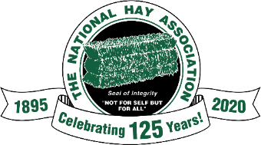
Agenda
2021 Mid-Year Membership Meeting
Thursday, March 18 and Friday, March 19, 2021
South Point Hotel – Las Vegas

Thursday, March 18

10 AM – 1 PM - Registration
Brunswick Rooms
1:30 PM - Welcome
Dan Wray, President
Brunswick Rooms
2:00 – Presentation – What’s new in Forage Equipment?
John Strieter-Streiter Hay Farms, Bay Port, MI.
John Russell – JD Russell Hay & Straw, Pemberville, OH
2:20 – Panel Discussion – Equipment Questions and Answers
3:00 – Presentation – How Covid 19 Pandemic Affected our Business?
Freeburg Farms, Gayville, South Dakota – Gary, Amy and Jory Freeburg
Border Valley Trading, Brawley, CA - Greg Jackson
3:30 – Panel Discussion – What does the future of hay markets look like?
4 PM – Break until Welcome Reception

5-9 PM - Cash Bar
Brunswick Rooms
6-7:30 PM – Welcome (Indoor) BBQ
Brunswick Rooms
Cash Bar until 9 PM
8-11 PM – Hospitality Room
Brunswick Rooms

Friday, March 19

7:15-8:45 AM – Continental Breakfast
Brunswick Rooms
8:30 – 10 AM…Annual Meeting
10 -10:20 AM Break
10:20 – Noon – Annual Meeting continues
12 Noon – 1 PM - Soup, Salad and Sandwich Lunch
1:15PM – 2:30 PM - Board Meeting Continues

